**Name :** Ritesh Jha

**Class :** P4 (IT)

**Roll No. :** 160104230**76**

**EEEE IA-1**

**Q2.** Calculate the current through 4 Ω resistor using Norton’s theorem. In the circuit shown in figure 2,the value of R1 will be the **last two digits of roll no. time’s Ω**

For eg: For Roll no: 1000020, then R1 = 20Ω. If your last digits are from 01 to 10, kindly add 10 to your last two digits, so roll no with last two digits with 01 will become 11, then R1 = 11Ω **(EVEN ROLL NO ATTEMPT Q2)**

Solve the numerical theoretical and measure IN, RN and current through 4 Ω load resistor (IL)

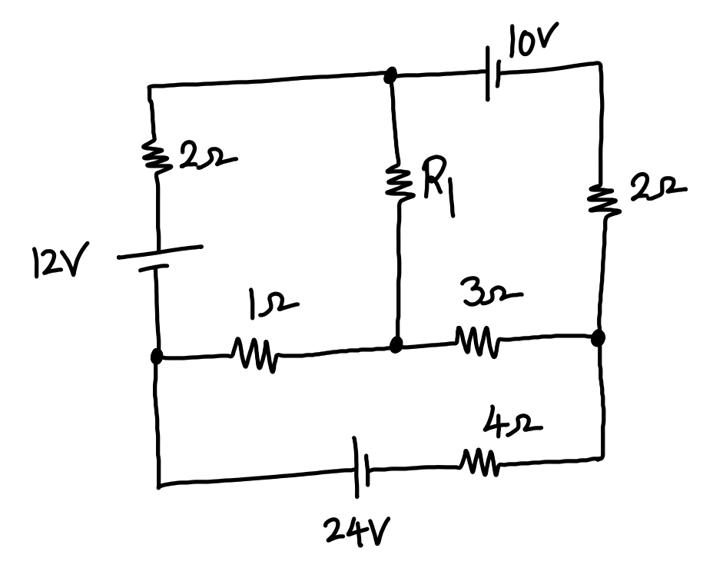

**Figure 2**

Simulate the circuit shown in figure 2, using LTspice software and measure IN, RN and IL. Tabulate the results as shown in the table below.

**Theoretical Calculations :**

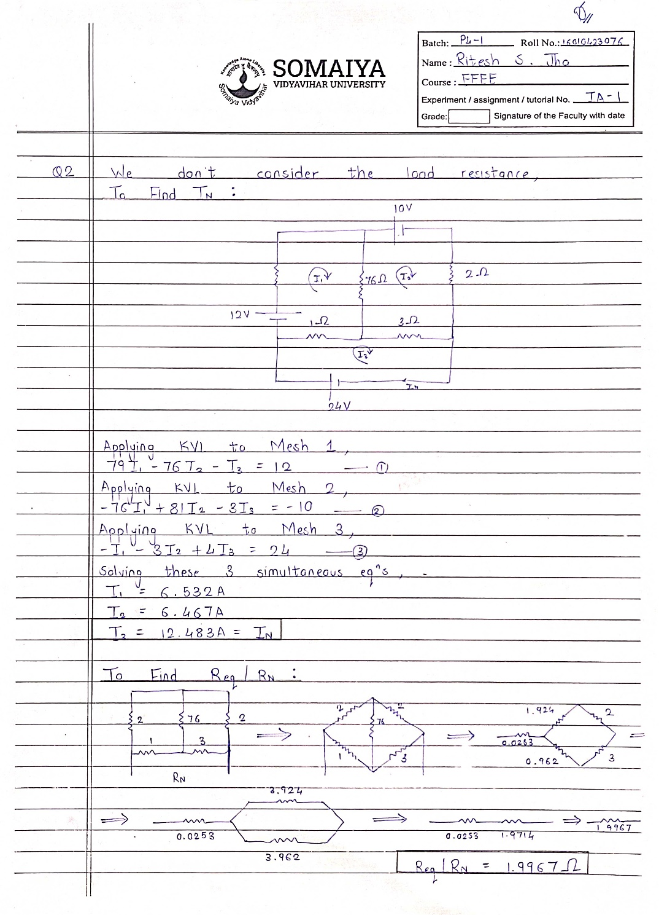

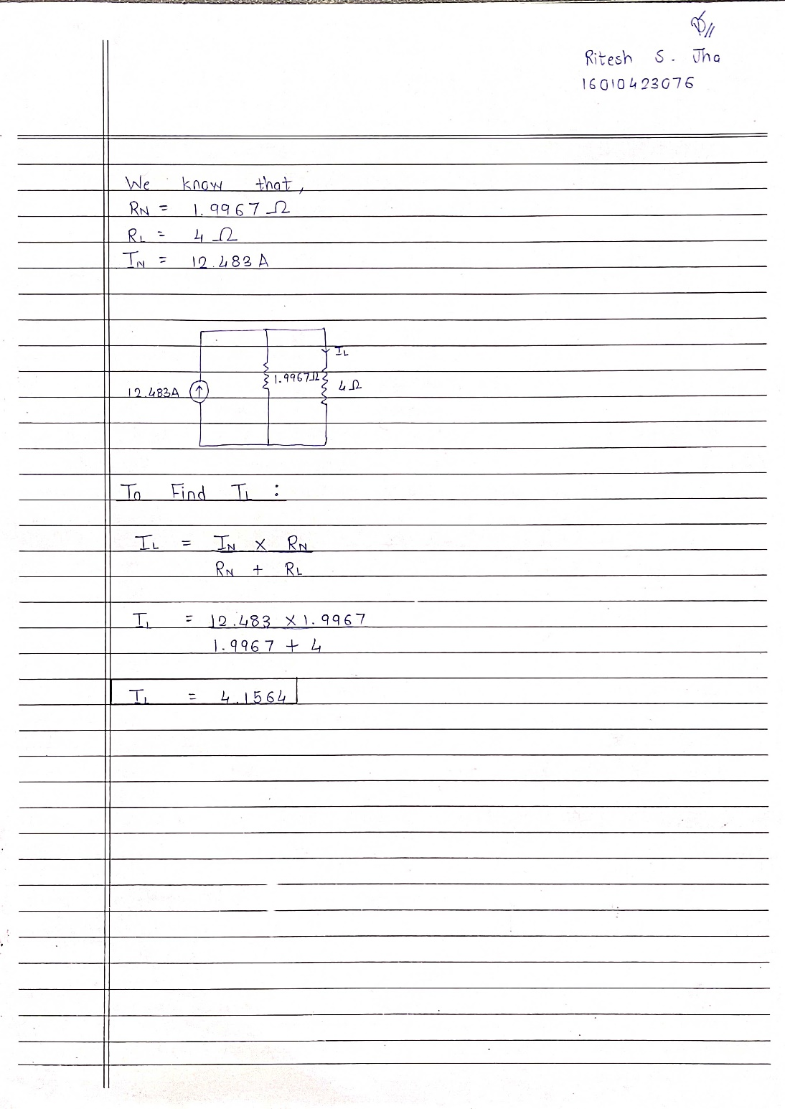

**LTSpice Stimulations :**

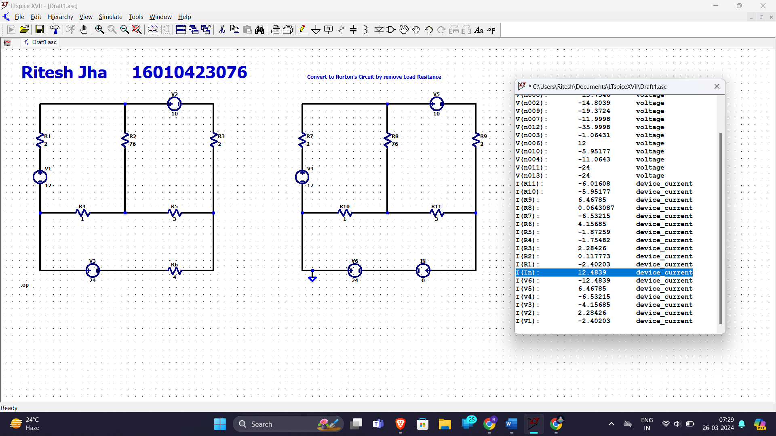

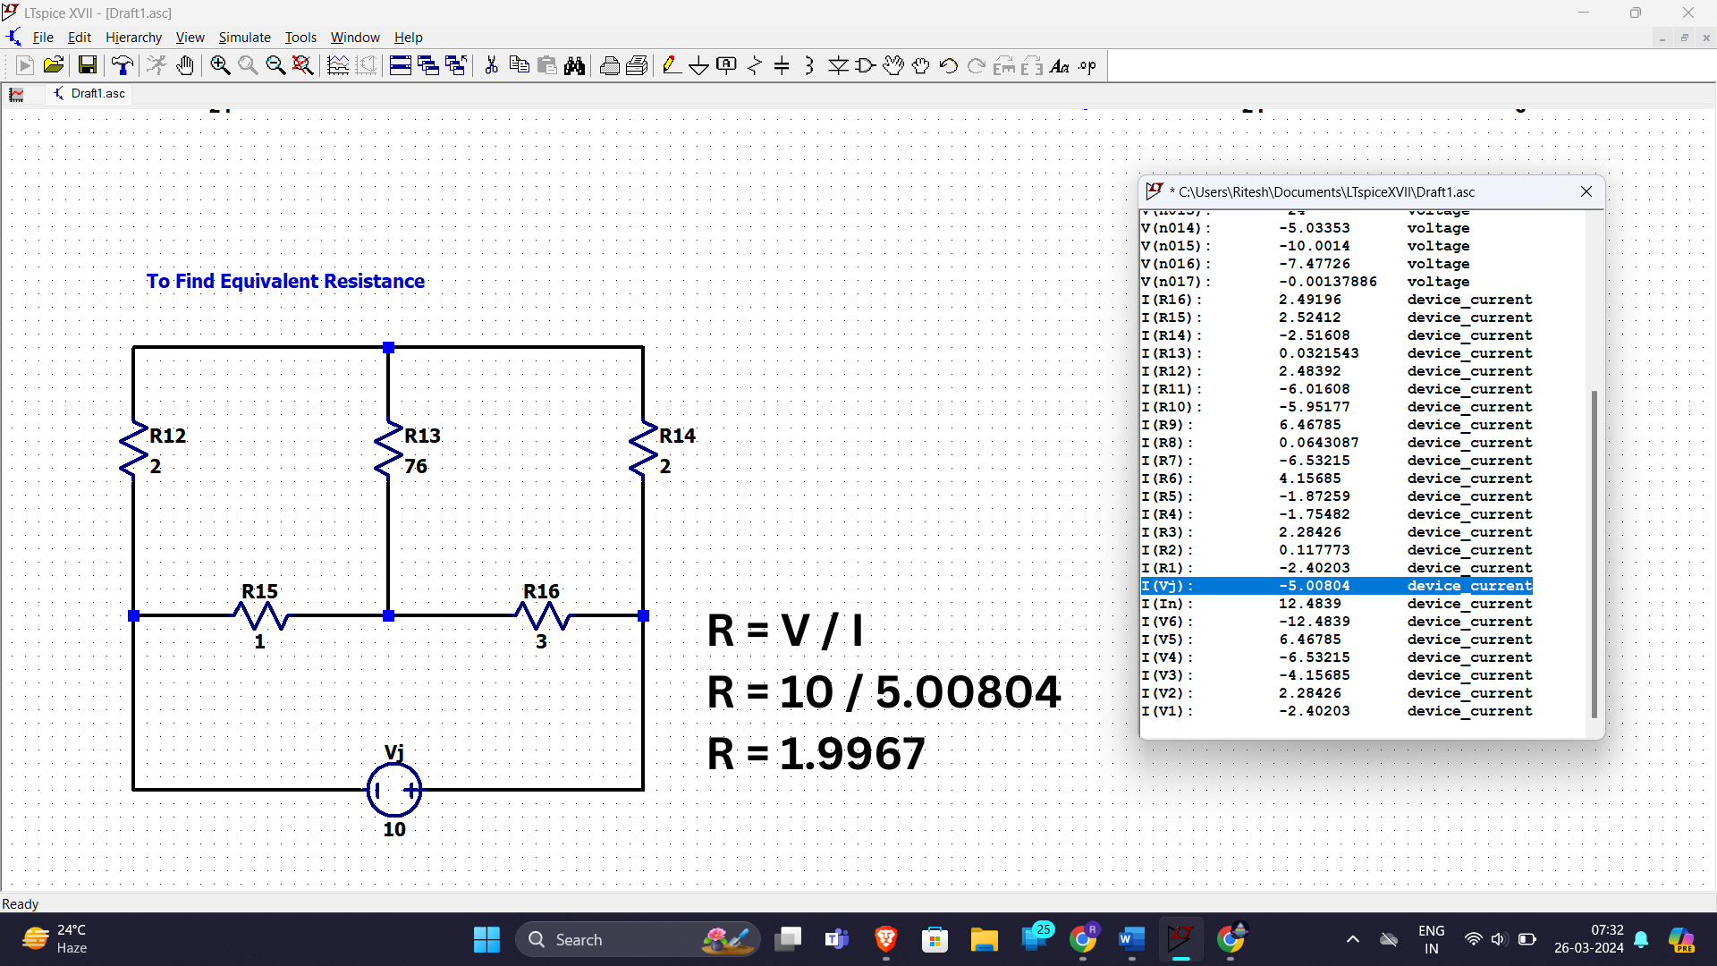

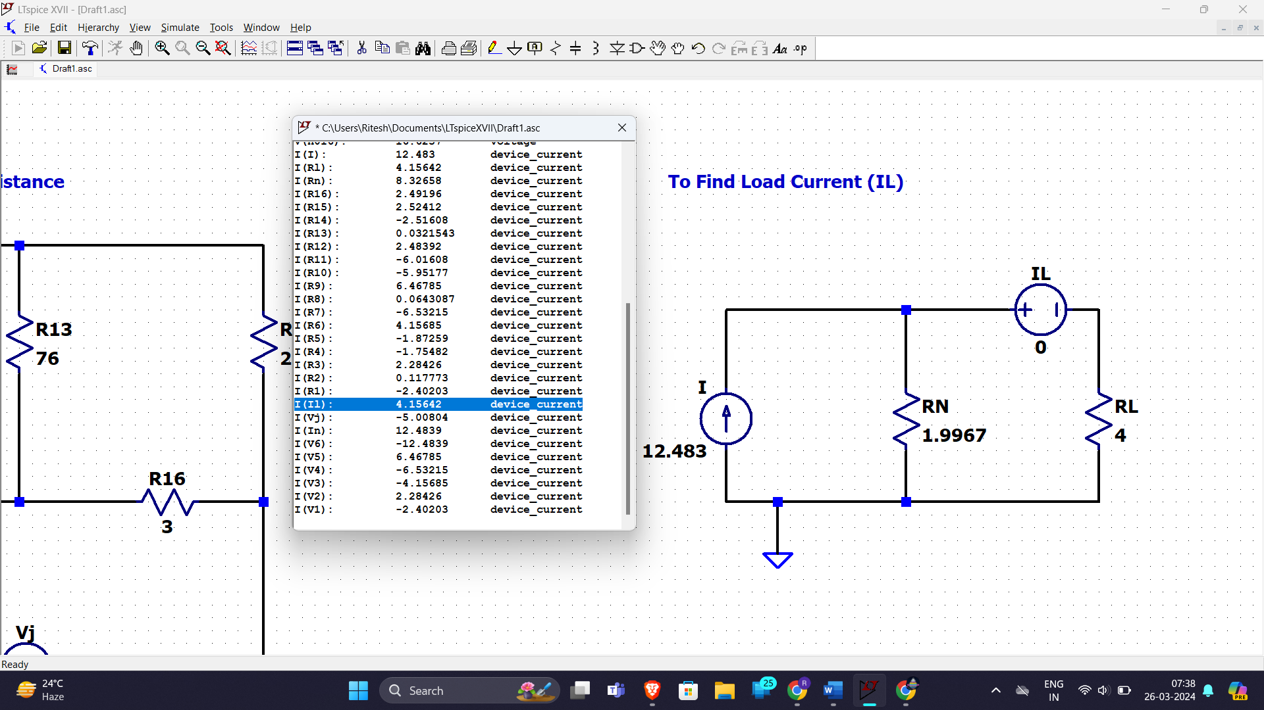

|  |  |  |
| --- | --- | --- |
| Parameter | Theoretical value | Simulated value |
| Norton’s current IN | 12.483 A | 12.483 A |
| Norton’s resistance RN | 1.996 Ω | 1.996 Ω |
| Load current IL | 4.156 A | 4.156 A |

**Q6.** Mention the types of batteries and explain the important characteristics for batteries.



